**Game Design Document**

**Overview**

Two Worlds is a short first person game teaching the player about the differences between first and third world countries.

The player begins the game by naming their two main characters. The characters are a first world businessman, and a citizen in a third world country. The player is able to control both of these players simultaneously, and explores the world to collect pickups to keep their player alive, such as water, food and medicine. A typical play through of the game is 10 minutes in length.

As the player progresses through the game, they will find it more difficult to keep the character in the third world country alive, as they face obstacles such as disease or lack of food. The player is able to donate some money from the first world player to the third world, to try and support them both adequately.

**Target Platform / Minimum Hardware:**

The game will be developed for the PC, built in the Unity Game engine. There are currently no plans to port the game over to other platforms compatible with Unity, however the usage of the Unity engine could allow for future versions of the game to be moved over to other platforms, such as iOS or Android.

The amount of resources required to run a game developed in unity vary significantly, depending on the scale of the game. As Two Worlds will be a relatively small game, the requirements will be low enough for the game to run on almost any modern PC. A brief summary of the recommended requirements are listed below.

Recommended requirements:

Operating System:

CPU: Dual Core recommended (AMD Athlon x2 or greater)

RAM: 2GB Recommended

GPU: DirectX9 Compatible GPU

Hard Drive Space: 1GB Free space recommended

Peripherals: Keyboard and Mouse

Minimum Screen Resolution: 1024*768 pixel display

**Visual Style**

Each of the two levels in the game is made to represent a different part of the world, and is made in its own distinct visual style. The environments consist of simple, low poly 3d models, styled after the part of the world they are representing. One of the main objectives of the visual style is to demonstrate to the player the different conditions of different parts of the world. To emphasise the difference between the two parts of the world, the colour palettes for each environment will be different. For more detailed examples of these assets, see the Assets section of this document. A breakdown of the styles is detailed below:

**World 1**

Modelled after: Modern day USA, 1st world country

Colour palette for environment: blue/grey

Environment: Tidy paved streets, tall concrete buildings

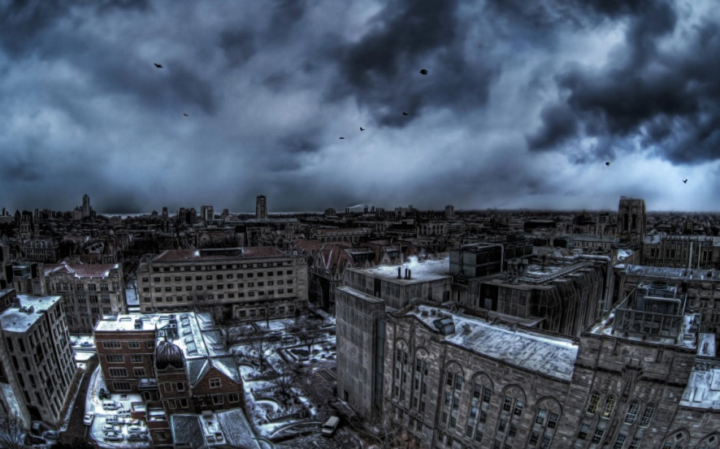

**World 2**

Modelled after: Ethiopia, 3rd world country

Colour palette for environment: red/brown

Environment: Sandy desert environment, small huts, less logical building layout

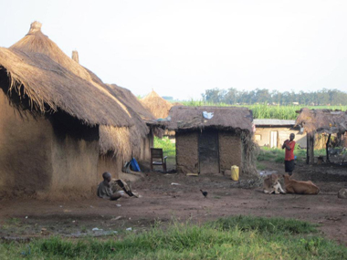

**Audio Style**

The game will use audio cues to alert the player of certain events in the game, such as when the player collects the various collectible items scattered throughout the map. A breakdown of the required sound effects presented in the Assets section later in the document.

In addition to this, there will be a background track being played throughout the course of the game. Because the player will be playing in both a 1st and 3rd world game, a track will have to be selected that captures the nature of the game, without favouring either particular environment.

There will be no voice acting required in the game, as the players in the game do not speak. The players not speaking allows the player to put themselves in the position of the characters, without the immersion being broken by hearing another person’s voice from the character they are controlling.

**Starting Out**

When the player first opens the game, they are displayed with the title of the game, and the option to start a new session. The game only offers a single game mode, which is single player. Once the player chooses to start the game, they are able to name their characters.

**Game start – Main Menu – Character Selection/Creation**

The main menu of the game has two options: the option to start a new game session, and an option to bring up the instructions on how to play the game.

The tutorial will describe the different collectibles in the game, how to control the individual characters, and how to donate money from one character to another. The menu will include small icons which represent each collectible, to give the player a visual reference of what to look for.

The option to start a new game will present the user with the option to name their two characters. Once these characters are created, the player is presented with a short backstory for each of the characters. When they have finished reading the story, the game will begin, and the player will be able to move the players and explore the game world.

**Game Start and Intro**

When the game begins, the player is presented with two screens side by side; one for each character. They are placed at the start point of their respective environments, and are allowed to explore as they choose and get their bearings.

Once the player begins to navigate through the game worlds, the collectibles will start to appear around the map. The spawn rate of these collectibles will vary, with the third world character getting noticeably less. In the beginning, the player will be given a short period of time before different scores, such as hunger and thirst begin to deteriorate. This will give the player time to become comfortable with the controls. While at the beginning of the game this will not be an issue, the player will soon find it difficult to keep the third world characters score high, with collectibles such as water being scarce.

**In-Game HUD & Menus**

The game interface will be split in half, with the third world player on the right, and the first world player on the left. There will be a window for each player to see the perspective of the player, and above each of these windows the players score will be presented. At the top centre of the screen, there will be a timer

The player will be able to pause the game at any point. In this menu, they are able to quit the game, which will return the player to the main menu. In addition to this, they are also able to turn the sound on and off using a button on the screen. A final option will allow the player to resume the game.

Further descriptions of the HUD and menu interfaces, along with visual references, can be found later in the document.

**UI**

**Main Menu**

The main menu screen simply displays the name of the game and then two option, the first being “Play”, to simply begin the game, with the second being “Instructions” takes you to another screen which just outlines the core premise of the game as well as your objectives and possible actions in the game.

**“PLAY”**

**“INSTRUCTIONS”**

**INSTRUCTIONS SCREEN**

**MAIN MENU**

**“BACK”**

**1ST WORLD CHARACTER NAME SCREEN**

**Player Customisation**

Once the player selects “PLAY” from the main menu, they will be tasked with naming their two characters. The initial screen will tell you to select the name of your 1st world character, via keyboard input. Once you confirm your choice via the “OK” button, the next screen will ask you to do the same again except for your 3rd world character. Once finalised, players are then provided with backgrounds for their characters, with their chosen names embedded into the stories; the two backgrounds shown side-by-side. The player then transitions into the game by clicking “START”.

**1ST WORLD CHARACTER NAME SCREEN**

**“OK”**

**3rd WORLD CHARACTER NAME SCREEN**

**“OK”**

**“BACK”**

**BACKGROUND STORIES SCREEN**

**“START”**

**INGAME SCREEN**

**Ingame Options Menu**

When the player brings up the in-game options menu, a simple box menu appears in the center of the screen with four options, “RESUME”, “INSTRUCTIONS” and “END GAME”, as well as a tick-box for “MUTE”, which mutes all sound when ticked. The “INSTRUCTIONS” option takes you to the same screen from the Main Menu.

RESUME

INSTRUCTIONS

END GAME

**2 WORLDS**

MUTE

**In-game HUD**

The In-Game HUD is designed to show the each character’s various stats along the top of the two screens, such as “HEALTH”, “MONEY” and “HAPPINESS”; these are also colour coordinated, in order to help with pick-ups. There is also a global timer shared between the characters, showing the amount of time left for the game.

1st WORLD

INGAME SCREEN

3rd WORLD

INGAME SCREEN

HEALTH: 100

MONEY: $427

HAPPY: 82

HAPPY: 31

HEALTH: 63

MONEY: $27

9:28

**Game Over Screen**

The Game-Over Screen displays the players end score, which is determined via combination of both characters happiness. The player is then offered the choice of restarting the game or ending the game.

**“RESTART”**

**“END GAME”**

**MAIN MENU**

**GAME OVER SCREEN**

**1ST WORLD CHARACTER NAME SCREEN**

**Mechanics**

**Split-Screen**

The game features a split screen mechanic, where the player plays as two characters simultaneously. For the purposes of this document I will discuss the mechanics for one character, and it can be assumed that the mechanics for the other character are the same unless stated otherwise.

**Movement**

The player has the ability to look left and right and move backwards and forwards to explore their environments. If a location is to be entered (e.g. a shop) then the player will be able to enter it by simply walking in to it.

**Stats**

Each player has a series of stats that must be maintained to keep them alive for the duration of the game. These are:

* Health
* Hunger
* Thirst
* Money
* Happiness

Hunger and Thirst will increase over time (the exact rate of which will be set during game balancing). Once they reach certain thresholds, the player will begin to loose health. The thresholds are as follows:

* 60+ - 4 point of health per cycle
* 70+ - 4 point of health per cycle
* 80+ - 4 point of health per cycle
* 90+ - 4 point of health per cycle

Note that these are the effects for both stats, so if a player reaches more than 90 Hunger and Thirst at the same time they would loose a cumulative 8 points of health per cycle.

**Pickups**

One of the main mechanics in the game is that of collecting various pickups in order to maintain their stats. These pickups will spawn randomly around the environment for the player to find and collect. The pickups and there effects are as follows:

* Medicine – Increases Health
* Food – Decreases Hunger
* Water – Decreases Thirst
* Money – Increases Money

Note that the amount of these pickups available in each player’s environment will differ to give an accurate reflection of real-world availability.

**Pop-Ups**

Each minute of the game, a pop-up will appear on screen for both players. These will fall into one of 3 categories based on Low, Medium or High Impact, and will either be positive or negative. The pop-ups will cause changes to stats. They will feature real-life problems/rewards and will be different for each player.

**Sharing Resources**

The main difference between the two players in terms of available mechanics is that the first world character has the ability to donate money to charity via a shop that can be entered in their environment. This money will be filtered down (as in real life) and a certain percentage will make it to the third world character. This will greatly benefit them as they will be able to use it to buy resources from the shops (see below).

**Shops**

In each player’s environment there will be a series of locations where resources can be exchanged for money. If a player has lots of money but is running low on a particular resource they can go and buy it.

# Controls

The player controls the game’s two characters at once, therefore requiring two sets of movement controls.

First world character controls:

* W key -> walk forward
* A key -> turn left
* S key -> walk backwards
* D key -> turn left
* ESC key -> open the pause menu

Third world character controls:

* UP directional key-> walk forward
* LEFT directional key -> turn left
* Down directional key -> walk backwards
* RIGHT directional key -> turn left
* ESC key -> open the pause menu

In the pause menu the player can use the mouse to select the options available.

# Modes

The only mode available for the player is an exploration mode in a large, free roam environment. The player roams the maps for 15 minutes while searching for pick-ups that effect the character’s current conditions.

# Winning the Match

The conditions for winning the game are as follows:

1. Both of the characters are alive when the time runs out.
2. One of the characters is alive when the time runs out.
3. The game has successfully counted down to 0 from 15 minutes

The conditions for losing are:

1. Both of the characters die by their HP reaching 0.

# Score

When the game has concluded the score shall be displayed on the screen. The score is calculated by taking the average of the health, happiness and wealth of each of the characters encouraging the player to help both characters rather than focusing on one. After the average of each of the characters has been calculated, the final score is an average of the average scores of the characters.

# Currency

The currency of the game will be in pounds sterling (£), both of the characters can collect money pick-ups that spawn within their environment. The money pick-ups will spawn more frequently in the first world environment than in the first world. In the first world environment the money pick-ups will be worth £100 and in the third world environment the money pick-ups are worth £10.

# Assets

The assets needed for this game will cover 3 sections, Collectables, 3rd world environment and 1st world environment. All these assets will be 3D and include a poly count budget.

## Collectables

These are the items that the player will collect and will be in the categories of food, water, medicine.

Food –

Carrots – poly count: 50

Apples – Poly count: 50

Bread – Poly count: 50

Meat – Poly Count: 50

Fish – Poly count: 50

Water

Jug – poly count: 50

Bottle– poly count: 50

Cup– poly count: 50

Medicine

Syringe– poly count: 50

Bottle of pills– poly count: 50

Plaster– poly count: 50

## 3rd world Models

These are the models in the 3D world; they will appear in the 3rd world view. They will come under two sections, buildings and props.

Buildings

House 1 – 250

House 2 - – poly count: 50

House 3 – poly count: 50

`Main village building – poly count: 50

Props

Cart– poly count: 50

Hay – poly count: 50

Clay pots – poly count: 50

Field – poly count: 50

## 1st world models

These are the models in the 3D world; they will appear in the 1st world view. They will come under two sections, buildings and props.

Buildings

Skyscraper – 250

Big business building - – poly count: 50

Big apartment complex – poly count: 50

Luxury Park – poly count: 50

Props

Car– poly count: 50

Lamp post – poly count: 50

Trash bin – poly count: 50

Field – poly count: 50

## Textures

These will be applied to the 3D models. They will all be 1024 x 1024 for high quality resolution. All the formats will be JPG.

## Naming conventions

The naming convention of each asset will be the section it is in, then the category, then the name, all words with a capital letter and only an underscore for the separation of sections. E.G.

Collectables_Food_Meat

1stWorld_Buildings_Skyscrpaer2

# Characters

Two characters are in the game, both with random back stories that are generated from one of 3 stories each. They will all just give an emotional investment in the character. They will be played through a first person camera at the same time. The only audio will be that of the characters walking.

Audio

An audio track in the background, of royalty free “elevator music” will be needed. Along with noises of pop ups, when collectables are collected, the sound of walking, death noise, this will include environmental noises like the sounds of a busy street.

**Back stories**

Both characters will be named by the player, but their individual backstories will be the same on each play through. The gender of each character is assigned by the name given by the player.

**Character 1 (1st world)**

The first world character is well off with a well-paying job, living in a busy, urban city. Being brought up in this environment the character is used to having both common place and luxury items at arm’s length, allowing for a healthy, relaxed lifestyle. With the first world map being full of resources, it will be easy to keep this level of health and happiness at a high level. Whilst they have all of this, their happiness can still be elevated by giving to those less fortunate.

**Character 2 (3rd world)**

The third world character is living in a struggling settlement based on existing developing countries. Being brought up in poverty, this character is used to working for their meals from a young age, having to travel long distances for safe water and having to share what little they have. They may not know any different than this way of living, but the struggle is still apparent. Their level of happiness is difficult to keep high, but surprises such as donations can make a big difference.